About Metanoia
Metanoia is a movement of people rooted in faith. We invest in neighborhood assets to build leaders, establish quality housing, and generate economic development. We are pushing forward into new relationships with God and one another to create strong communities. Metanoia envisions a diverse community of people that are inspired and empowered to make the community better for generations to come where:
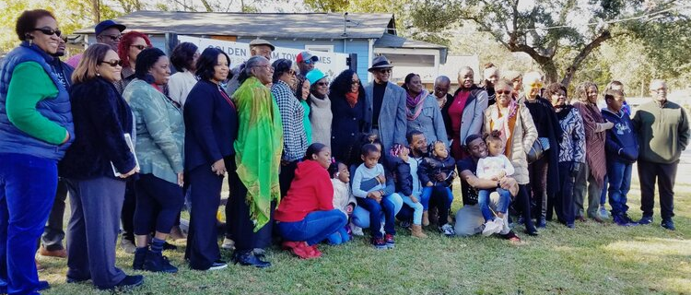
- Quality housing and livable wage jobs are accessible to all.
- There are academically achieving schools.
- Businesses and faith communities benefit the community.
- The quality of life includes green space and recreational opportunities.
- Reynolds Avenue is a hub of economic and social activities.

History Overview
In 2002, the Cooperative Baptist Fellowship of South Carolina desired to invest in transformative efforts to address childhood poverty within the state.
CBFSC’s coalition of churches hired Urban Ministers Evelyn Oliveira and Bill Stanfield to spend a year listening to residents and leaders within SC’s North Charleston neighborhoods and decided to focus its efforts on Chicora-Cherokee.
Metanoia’s Board was formed and built a partnership with St. Matthew Baptist Church. Metanoia’s first initiative, a small afterschool enrichment program for 1st-4th grade students of Chicora Elementary, launched in 2003. Since that time, Metanoia’s initiative to build leaders has grown into a year-round youth leadership development program for scholars from 1st through 12th grade and an integrated community development effort.

What We Do
- Build Leaders - Metanoia Youth Leadership Academy builds leaders of character, excellence, and presence. Our youth leadership pipeline identifies and invests in the assets of each leader from elementary to high school.
- Establish Quality Housing - We work to develop quality housing and homeownership opportunities with neighborhood residents. We are working to proactively combat displacement due to increasing demand for local housing and rapidly rising housing prices .
- Generate Economic Development - Metanoia invests in neighborhood assets to generate economic development. We support Black and Brown entrepreneurship in the neighborhood from youth to adulthood, and work to connect residents with livable wage jobs.

Our Approach
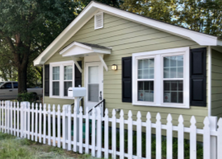
Asset-Based | Community-Driven | Rooted In Faith
We see our neighborhood as a ‘glass half-full’ rather than a ‘glass half-empty,’ and we work to discover and grow community assets through investing in those assets. | We are committed to active listening and collaboration that includes citizen participation and buy-in for positive change. The community residents on our Board and Staff are essential to our decision-making process. | We see and believe in a bright future for our community in spite of circumstances, then we watch circumstances change. We provide good ground for people to nurture and grow their faith.
Our Culture
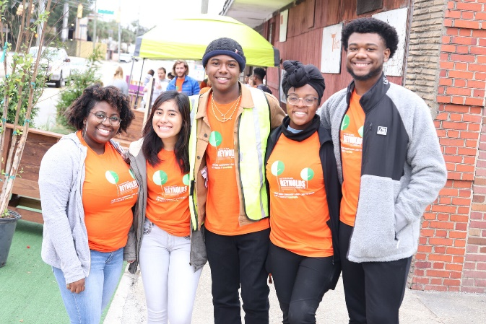
Metanoia is collaborative, relaxed, and results-oriented with a strong culture and reputation that depends on everyone being open to growth and transformation. It is the nature of our work together to experience days of both exhilaration and heartache but faithfulness to our mission remains more important than any victory or loss we may experience. “Love and justice are not two. Without inner change, there is no outer change.” For these reasons:
- Taking time to reflect and reconnect ourselves to God and one another is as important as any work we do in our community.
- We are a learning community where personal growth is critical to the success of our work together.
- One of Metanoia’s practices woven into the fabric of team meetings is a moment of silence. This allows the team to locate ourselves, hold the tension between our intentions and where we are, listen generously to ourselves, slow down enough to see one another.

Position Summary
The Senior Director of Administrative and Financial Operations develops, manages, and pursues continuous improvement of internal support systems and processes that enable Metanoia to achieve its goals for growth in accordance with its mission. The SDAFO oversees all administrative operations, including employee compensation and benefits, finance and budgeting, third-party contracts and vendor services, risk management, records retention, IT and telephone systems, and property maintenance The SDAFO also serves as administrative compliance officer to the Board of Directors and is the day to day liason to the outside accounting firm.

Reports to: Chief Operations Officer
Location: North Charleston, SC

Areas of Responsibilities

Executive Leadership
- Serves as a member of the organization’s executive leadership team, participating in the development of the strategic plan, annual operating plans and budget.
- Identifies key performance indicators (KPIs) to monitor and assess administrative performance.
- Recruits, manages and evaluates administrative staff (2.0 FTE), and manages the work of contractors and vendors related to the successful accomplishment of the functions listed below.

Fiscal Leadership:
- Serves as primary interface with full services external accounting firm to assure excellent fiscal management of the organization.
- Proactively evaluates fiscal outcomes of existing and new projects to assure organizational fiscal health and sustainability.
- Serves as primary staff liaison to Metanoia’s Finance Committee. Assures that fiscal information is provided in a useable and understandable manner to employees and Board of Directors.
- Ensures compliance of Financial Policies and Procedures and assure that these remain updated, relevant and comply with established ongoing review process.
- Oversees financial processes, including weekly invoicing and credit card processing
- Works with Directors and Leadership to ensure monthly financial workbooks are complete.
- Works in coordination with external accounting firm to ensure timely, accurate financial reporting for housing repairs, residential and commercial rental and property construction.
- Ensures reimbursement requests are timely and accurate.

Administrative Leadership
- Establishes and maintains employee compensation and benefits programs to facilitate attraction and retention of top talent.
- Supervise payroll and benefits administration processes.
- Supervise technology and telecommunications vendors.
- Establishes and ensures compliance of internal administrative policies.
- Supervise approval and management of contractors and vendors.
- Manages performance, maintenance, and upgrades systems.
- Supports the CEO and COO to ensure the Board of Directors is properly educated and informed regarding administrative matters relevant to organizational performance.

Risk Management & Asset Protection
- Works in conjunction with leadership to identify potential risk and to mitigate potential harm including obtaining and managing insurance coverage as required by law and as needed to protect the organization, its stakeholders and its assets.
- Conducts ongoing risk assessment and develops and implements risk mitigation strategies.
- Is proactive in assessing risk, viability and sustainability of organizational projects. Works with CEO and COO to establish vetting processes to assure these factors are considered.
- Develops and implements strategic plans and processes for maintenance and repairs for all organization properties, including offices and classrooms.
- Support the administrative processes involved in strategic plans and processes for securing and maintaining Metanoia assets.

Compliance
- Serves as administrative compliance officer for the organization, ensuring adherence to legal, regulatory, grants administration, and financial policy requirements.
- Establishes and ensures adherence to records retention and documentation policies.
- Develops and maintains Dropbox (or similar) folder/file structure and naming conventions.
- Ensures organizational documents are approved and filed appropriately, and that files are complete.

Requirements:
- Bachelor’s degree in business, accounting, or finance or equivalent experience; MBA preferred.
- A minimum of 6 years of experience in the management of administrative and finance operations, with at least 2 years in a supervisory capacity.
- Commitment to Metanoia’s mission, values, and growth.
- Ability to work in an environment with people of different race, economic backgrounds, and lived experiences. Ability to model inclusive practices.
- Excellent written and verbal communications skills.
- Working knowledge of critical administrative functions, including finance, human resources, IT, and risk management.
- Strong leadership and teamwork skills.
- Ability to plan, organize, and manage projects through to meet deadlines and achieve desired goals.
- Excellent problem-solving and decision-making skills.
- Ability to juggle priorities and adapt to a changing environment.
- Proficient technology skills.

Physical Requirements
- The Senior Director of Administration and Financial Operations must have the ability to work in an office environment, sitting at a desk for long periods of time.
- Metanoia’s offices are located on the third floor of an historic church building with only stairs for access to the space.
About North Charleston, SC
North Charleston, SC is a diverse and progressive city and sits in the heart of the SC Lowcountry. The City was birthed around the former Charleston Naval Shipyard which opened in 1901. Since the closure of the base in 1996, the City has undergone a renaissance of arts, culture and new residential and business growth. North Charleston has been the number one retail and shopping destination in South Carolina for over two decades and its communities are filled with longtime residents and new comers working for businesses like the Boeing Company that have also chosen to call North Charleston home.

The Charleston Area has what many would consider perfect weather. For most of winter, the temps usually don’t drop below the 50s. Summers can get pretty hot, but thankfully, the rivers and oceans nearby provide consistent breezes. There are three beaches within a 20-minute drive from North Charleston, offering plenty of opportunities to cool down: Sullivan’s Island, Isle of Palms, and Folly Beach.

North Charleston is also a great place to raise a family as it offers a variety of parks, good schools, and a thriving economy. Charleston is home to many exceptional educational institutions. Whether your ideal classroom is Montessori, traditional, or Christian-based, we know that you will find the perfect learning environment for your child’s individual needs. The region is home to the 2nd largest school district in SC and very prominent colleges and universities such as Medical University of South Carolina (MUSC), The College of Charleston, The Citadel (one of the most prestigious military colleges in the country), and Charleston Southern.

Whether you’re wanting to live close to downtown or out in the suburbs, the Charleston area has a real estate offering that’s perfect for you. North Charleston has diverse neighborhoods with a variety of housing price points. North Charleston sits in the center of the Lowcountry and is a short drive to one of the area’s pristine beaches, beautiful outdoor parks and local historic sites. North Charleston has its own award-winning restaurants and is a 10 minute drive from downtown Charleston and all that it has to offer.

Charleston’s economy has been growing rapidly over the years and can attribute most of its success to the local harbor and companies like Boeing, Volvo, MUSC that continue to add thousands of jobs to the area. The influx of travelers into Charleston, especially during the summer months, makes tourism another promising industry of the city. A variety of jobs are available during the summer periods, mostly for the service and hospitality sectors. Charleston’s unemployment rate is 2% lower than the US average of 6% and has seen a job market increase of .7% over the last year.

Local dishes in Charleston are among the best in the country. Shrimp and Grits and She-Crab Soup are the top local dishes that you can’t afford to miss after moving to Charleston. Residents of Charleston also enjoy a sweet combination of backyard oyster roast with Frogmore stew.

For more information on North Charleston and surrounding areas, you can also visit:
- https://visitnorthcharleston.com
- https://www.charlestoncvb.com/

